Where to report Anti-Social Behaviour

Where to report issues at Tonbridge and Malling Borough Council

To report Anti-Social Behaviour

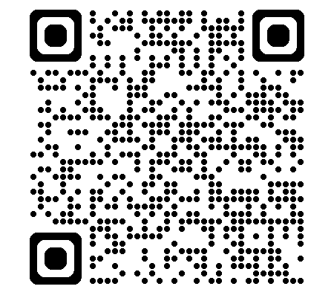
https://bit.ly/tmbcasb

To report noise issues to the Environmental Protection Team
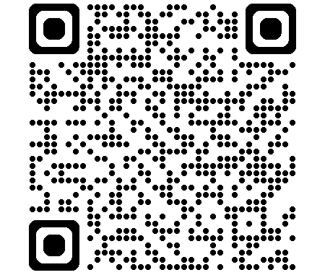
https://bit.ly/tmbcnoise

To report parking issues

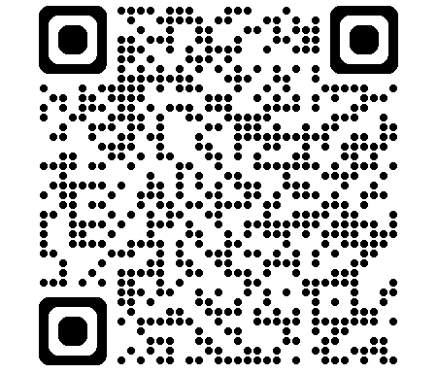
https://bit.ly/tmbcparking

To report fly tipping and street waste issues
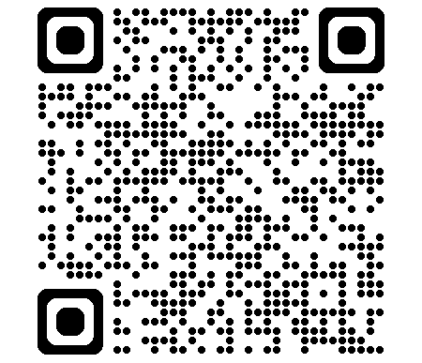
https://bit.ly/4xfP9Ge

Where to report issues at Kent County Council
To report potholes, drainage, pavements, overgrown foliage foot paths etc. | 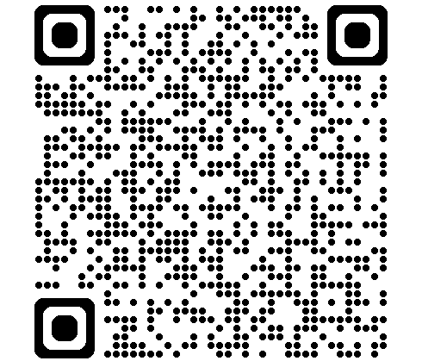  https://bit.ly/4ueG8tW
For Social Services concerns for adults and children | 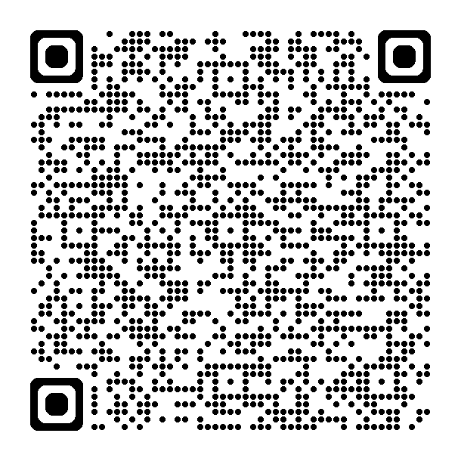  https://bit.ly/4ul2RES

Where to report issues to Clarion Housing Association

To report issues regarding a Clarion housing property:

Clarion Housing Contact Centre customerservices@myclarionhousing.com or telephone 0300 500 8000

How to report to the Police

All crime should be reported to the police. This includes drug dealing, the use of illegal bikes/motorised vehicles or abusive behaviour.

In an event of emergency call 999. For non-emergencies call 101 or go to www.kent.police.uk

You can also report anonymously to Crime Stoppers on 0800555111 or
www.crime-stoppers.org

