Public Consultation – Speed Indicator Device
As part of its Highway Improvement Plan, Hildenborough Parish Council has been working closely with Kent County Council to identify opportunities for safety improvements in areas of the village where highway safety is considered to be a concern.
One proposal put forward by the Council is the installation of a mobile Speed Indicator Devices (SIDs) which will move between three locations within the village. This device displays a vehicle’s current speed to drivers, encouraging those over the limit to reduce their speed within the 30mph zone.
Speeding has been identified as a particular concern by the village Speedwatch team, especially along the B245. Following discussions with Kent County Council, three potential locations along this route have been identified that meet the necessary criteria for installing these devices.
The Parish Council would like to hear the views of residents on this proposal.
The three locations proposed are:
• B245 Tonbridge Road (grass verge outside Nos. 8/10) – one direction
• B245 Tonbridge Road near Brookmead – both directions
• B245 London Road adjacent to Foxbush – both directions

Or as seen on the map below
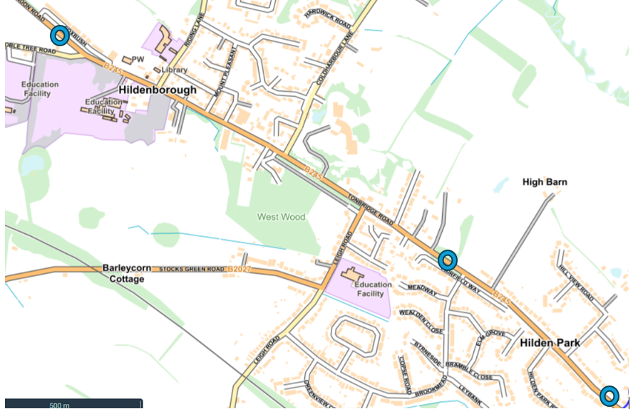

- Do you support the installation of Speed Indicator Devices (SIDs) in Hildenborough to encourage drivers to reduce their speed?
☐ Yes
☐ No
☐ Unsure

- How concerned are you about speeding in Hildenborough, particularly along the B245?
☐ Very concerned
☐ Somewhat concerned
☐ Not very concerned
☐ Not concerned at all

- Do you think Speed Indicator Devices will help reduce speeding in the village?
☐ Yes
☐ No
☐ Unsure

- What is your connection with Hildenborough?
☐ A resident
☐ A relative of a resident
☐ I work in Hildenborough
☐ Children attend school in Hildenborough
☐ I drive through Hildenborough regularly
☐ Other (Please specify)____________________

- What is your age?
☐ Up to 25
☐ 26 – 40
☐ 41 – 64
☐ Over 65
☐ Prefer not to say

- Do you have any other comments about speeding or road safety in Hildenborough?

Please return your form either by email to: clerk@hildenboroughparishcouncil.gov.uk or to the post box at The Pavillion, Recreation Ground, Riding Lane, Hildenborough, TN11 9HY

