West Wood Ash Dieback Works
What is Ash Dieback?
Ash dieback is a serious disease affecting ash trees, caused by a wind‑borne fungus that spreads through the leaves and branches.
Infected trees gradually weaken, with the crown thinning and branches dying back. Although some trees decline slowly, many deteriorate within just a few months, creating safety risks as they become unstable.
The disease is now widespread across the UK and is expected to kill a large proportion of ash trees
Hildenborough Parish Council would like to update residents that essential works will shortly begin in West Wood to address the ongoing issue of ash dieback. The woodland has been experiencing decline, with many ash trees deteriorating rapidly despite regular tree surveys. Trees that appear healthy can die within just a few months, creating significant safety risks for woodland users.
To ensure public safety and protect the long-term health of the woodland, the Parish Council plans to remove all affected ash trees. The felled material will be chipped and used to improve pathways throughout West Wood, helping to manage footfall and maintain safe access for visitors. Please be aware there may be short-term restrictions on access to some areas of West Wood, for public safety.
Ecological Benefits and Biodiversity Recovery
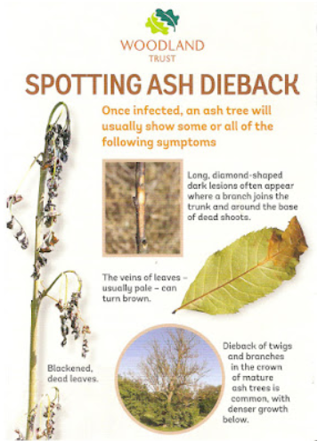
The restoration work is designed to support the woodland’s long-term ecological resilience. Removing diseased ash will increase the amount of light reaching the woodland floor, allowing suppressed native ground flora to re-establish. This will encourage natural regeneration of a wider mix of broadleaf species, including oak, birch, hazel and hawthorn. Over time, this will create a more diverse and structurally varied habitat, reducing the risk of future disease-related decline.
The project will also enhance biodiversity through the creation of deadwood habitats. Chipped material used on pathways and retained brash piles will support fungi, invertebrates, amphibians and small mammals, contributing to a richer and more balanced woodland ecosystem.
Improved Access for the Community
Improved pathways will help reduce soil compaction, protect regenerating areas and ensure that residents can continue to enjoy West Wood safely.
By addressing ash dieback proactively and guiding West Wood toward a more diverse and resilient future, this project will secure long-term ecological benefits, improve habitat quality, and enhance public enjoyment of this valued local space.

